|  |
| --- |
| GDT4-2021 |
| Pilgrimage |
| 10-Page Design Document |

|  |
| --- |
| Your Own Game 5  3-14-2021 |

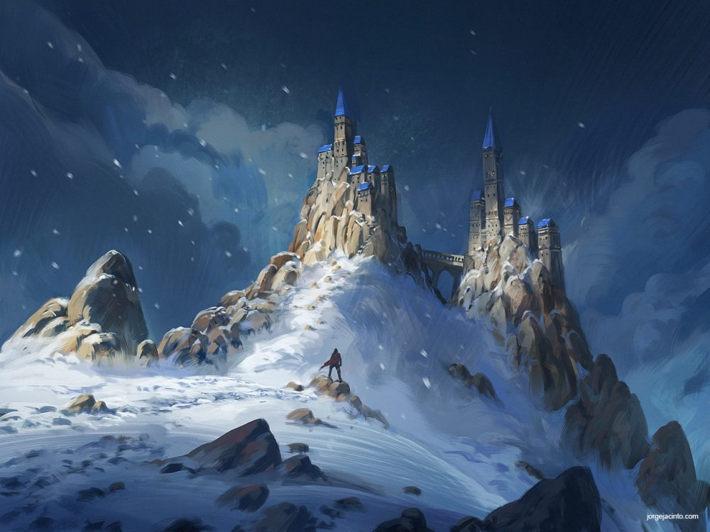

Table of Contents

Game Description 3

Game Story: 3

Game Play/Experience: 3

Unique Selling Points: 3

Elevator Pitch: 3

Game Elements 4

Kind of Fun: 4

Theme/Mood: 4

Boundaries & Setting: 4

Game World: 4

Characters: 4

The Traveler 4

Enemies 4

Storefront Description 5

Core Loop: 5

Explore: 5

Puzzle/Encounter: 5

Checkpoint: 5

Intensity Graph: 6

Story elements: 6

Game mechanics: 6

Audio-visual Elements: 6

Similar Competitive products: 7

Game Design 8

Player Character: 8

World: 9

Enemies: 9

Secrets: 10

Game Mechanics 11

Wall-running: 11

Bow: 11

Puzzles: 12

No Combat: 12

General Mechanics and Controls 14

Movement: 14

Checkpoints: 14

# Game Description

## Game Story:

In a world full of mysteries and monsters, the traveler ventures beyond the safety of his town, Seliana, to fulfill his brother’s dying wish, to have his remains scattered alongside his family. Join the traveler’s journey as he faces unfathomable creatures, reminisce his old memories, and treacherous paths as he fulfills his brother’s final wish.

Follow the traveler as he grows as a person and learn to deal with the loss.

## Game Play/Experience:

The traveler is a very agile and meticulous adventurer and that is shown in his controls. Players will enjoy a high skill-cap fast paced movement system that will make the player feel good when traversing the levels. The movement system is inspired by the Titanfall series and Ghostrunner. The world is a hybrid of Open-World and Theme-park inspired by Tombraider and Ashen and will offer parkour challenges, dangerous enemy encounters, light navigation puzzles and well kept secrets.  
  
In order for The Traveler to complete his brother’s wish he will need to acquire a set amount of key items from different types of trials. These can include but are not limited to: Parkour challenges and puzzles. Along the way, players will encounter deadly enemies and monsters, and, as the traveler is no fighter, players will have to sneak their way from the enemy’s territory, as one mistake could be the player’s last.

## Unique Selling Points:

* Fluid movement mechanics
* Acquire progressively stronger weapons and abilities
* Beautiful Stylized World
* Deep and engaging story
* Encounter unique monsters and enemies
* Various stealth mechanics to sneak through enemies

## Elevator Pitch:

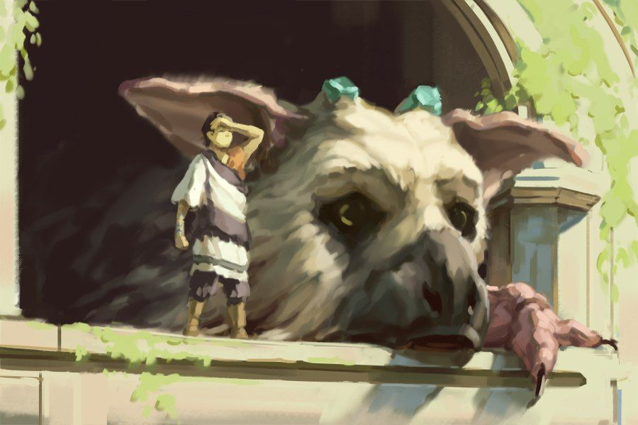A 3D First-person platformer/adventure game with immersive narrative story that portraits the spiritual journey of the main character that is equipped with a bow to solve puzzles and faces dangerous enemies along its journey and set in a fantasy world. In short, The Last Guardian in First-Person with parkour.

# Game Elements

## Kind of Fun:

1. Sensation:
   1. Our game will include beautiful landscapes and areas for players to explore as well as an interesting way to do this exploration.
2. Narrative:
   1. We are planning to place an immersive story into the game, to show the players why our character is doing this journey and purpose of it.

## Theme/Mood:

1. Theme: Spiritual Journey.
2. Mood: Transitioning from grief to acceptance as the story progresses.

## Boundaries & Setting:

1. Boundaries: Cliffs, trees, inaccessible paths, etc.
2. Setting: Mountains and forest, occasional towns/small villages if possible.

## Game World:

We wanted a game world that is open that can also be served as a levels/stages, such as the world of Journey and The Last Guardian. There are several stages in the game and as the player progress in stages, the story progresses as well. In every stage, there will be some puzzles that mostly required to be solved in order for the story to progress, however there are some puzzles that are not compulsory. These are usually puzzles that contains secrets and lore to the game. Beware that in every stage, there will be enemies lurking, so players must be able to avoid these monsters as it may result in their death. As for the aesthetics, we want the player to feel perilous and natural during the journey, hence it will mostly consists of mountainous paths and forest meadows.

## Characters:

Seeing as the plan is to make the player journey alone, as for the moment there will be only one character (The Traveler) and some enemies.

### The Traveler

#### Aspects:

* Hit points: 2 HP.
* Cannot fight.
* Avid Climber.
* Equipped with Bow and arrow.

### Enemies

#### Aspects:

* Unkillable.
* Roams in the land in every stage.
* Have stages of detection.

## Storefront Description

Inspired by Journey and The Last Guardian, Pilgrimage is a First-person Adventure game set in the beautiful world of the Kingdom of Valaris. Join The Traveler’s spiritual journey as he ventures to his family’s grave to fulfil his brother’s dying wish using nothing but his acrobatic skills and his trustworthy bow.

## Core Loop:

### Explore:

* + Players will enter the world of Pilgrimage, where they can either focus on the story, or uncover the land’s mysterious secrets.

### Puzzle/Encounter:

* + Players will often find themselves tangled with either a puzzle of some sort or an enemy encounter in which they must evade during the exploration.

### Checkpoint:

* + Players will be met with a bonfire that serves as checkpoint before moving to the next stage. In this checkpoint, players health will be restored.

## Intensity Graph:

### Story elements:

In this part, the intensity of the events are being shown/described by a small cutscene that explain the events.

Events affected:

* Attending Funeral
* Receive Letter
* Leave Hometown
* Arrive at Grave
* Contemplation

### Game mechanics:

In this part, the intensity of the events are being shown/described by mechanic(s) that becomes available for the players to use.

* Start Journey
* Encounter Puzzle
* Encounter Enemy

### Audio-visual Elements:

In this part, the intensity of the events are being shown/described by the audios and visuals of the world surrounding the events. For instance, at the start of the journey, players enters into the world of Pilgrimage and is welcomed by the spectacular and beautiful landscape of the world.

Events affected:

* All

## Similar Competitive products:

Figure 1, The Last Guardian

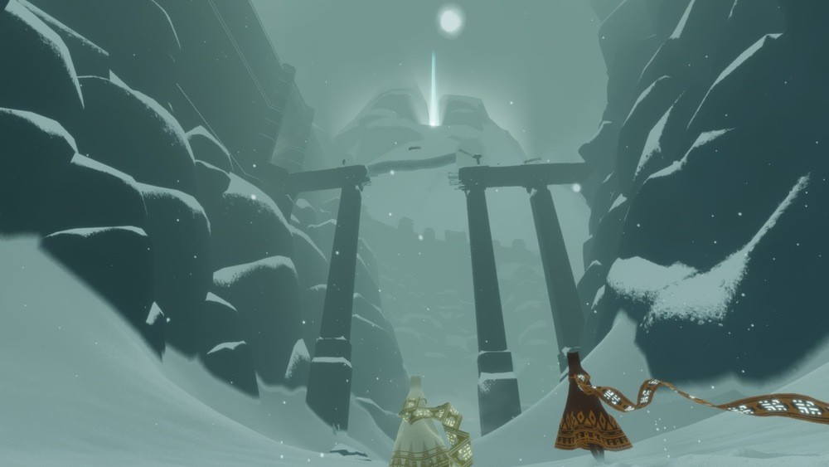The Last Guardian is the main inspiration of this game, it inspires our game world, boundaries and setting, as well as the types of game pleasures.

Figure 2, Journey

Journey is also a big inspiration to our game, it inspires our game world as well, but mainly the narrative storytelling and the theme/mood of our game.

# Game Design

## Player Character:

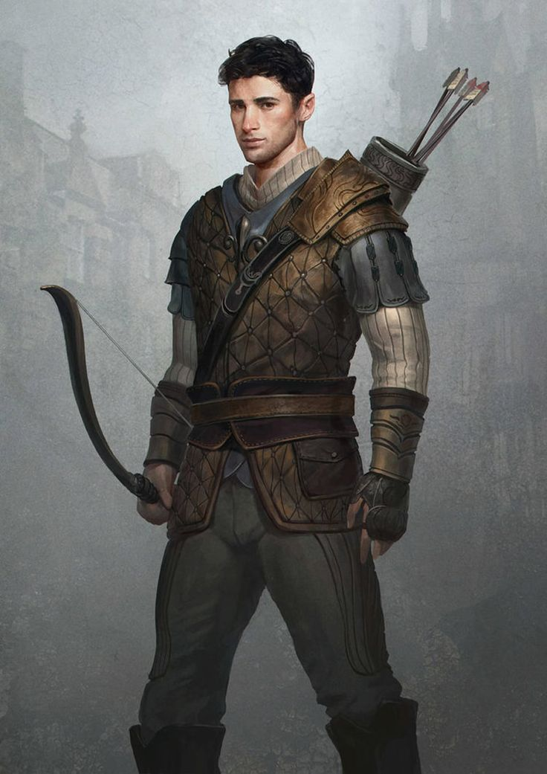Meet the Traveler a brave adventurer from the town of Seliana, whom shall fulfill his brother’s dying wish. Equipped with a bow and acrobatic skills, he must venture through the beautiful yet treacherous lands of the kingdom Valaris. On his path, he will face many dangerous mountain passes, deadly beasts, and many secrets in which the kingdom holds.

## World:

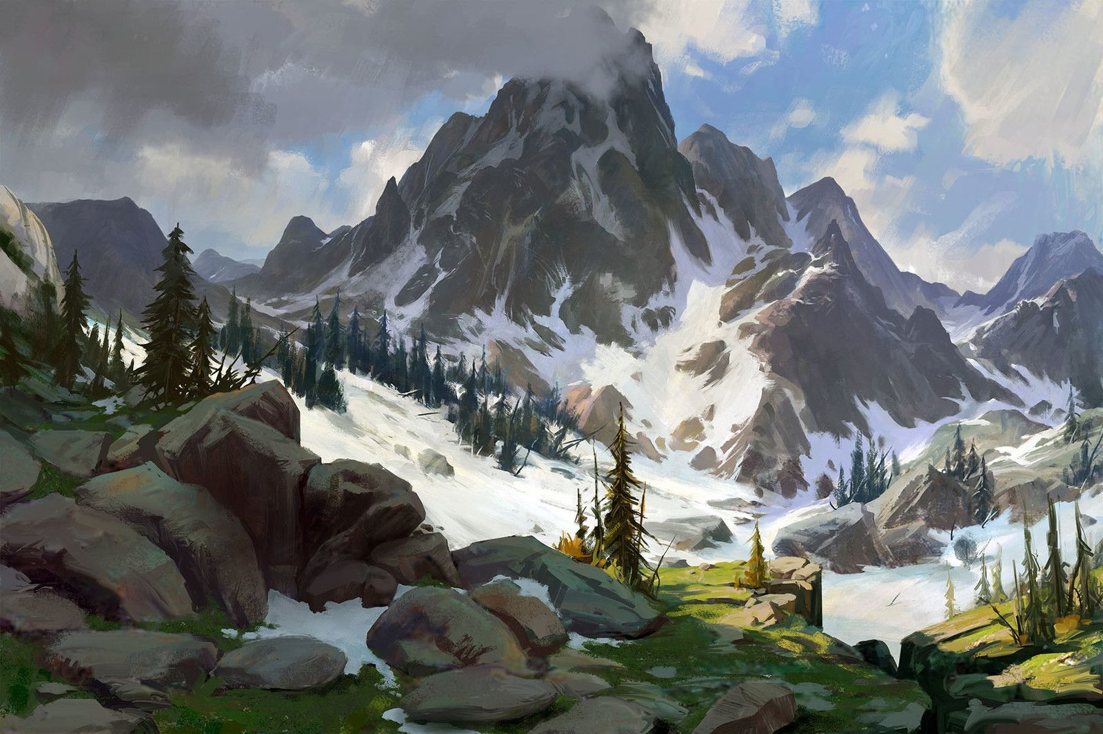The kingdom of Valaris is a beautiful yet mysterious kingdom, filled with many dangers and wonders blessed by nature itself, scattered across the lands. The Journey to his family’s grave is filled with many mysterious and dangerous path, with monsters that lurks in every corner of the land. The traveler will discover many mountainous path and old ruins as he travels to his family’s grave.

## Enemies:

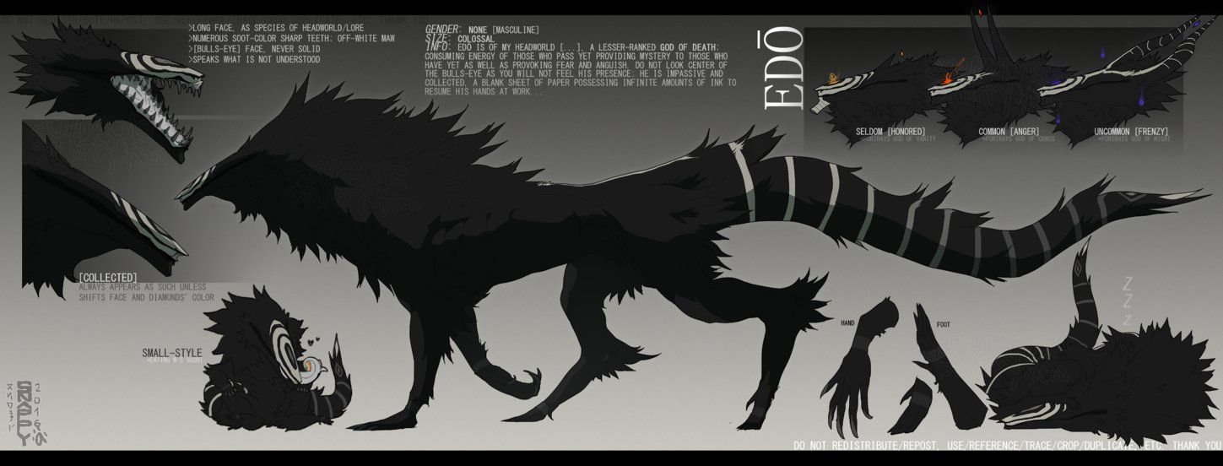The monsters that lurks in the corner of the Kingdom of Valaris are known as beasts of the old. Legend says that they have exist long before civilisation exists in that Kingdom. They are fierce creatures with deadly strength and agility, and with its thick hide and skin, they are invulnerable to any physical attacks. As the traveler, he must avoid contact at all cost if he were to value his life and if he were to fulfil his brother’s wish.

## Secrets:

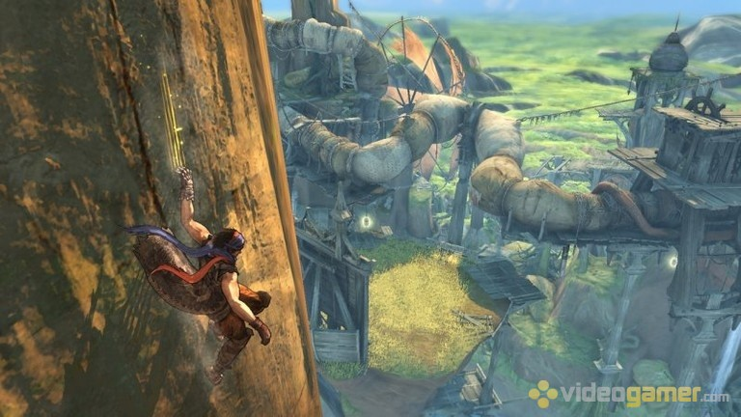The Kingdom of Valaris is filled with many mysteries and secrets. As the traveler ventures to his family’s grave, he will be met with many secrets that he must solved in order to help him on his journey. In addition, the secrets that he solves may contain stories of the old civilization that tells the lore and ways of the first civilization that exists on the Kingdom.

# Game Mechanics

## Wall-running:

The wall-running is the core mechanic in our movement system. This is inspired by the works of respawn entertainment Titanfall series. So the idea is to give players a more fluid movement in the game because the movement system needs to give players an easier way to explore the world of Pilgrimage, since the world is made up of many mountainous paths.



## Bow:

The bow is used mainly for solving puzzles. The idea is that players will use the bow to shoot tiles or platforms with the bow to solve the puzzle. Of course the arrow will have a trajectory system in which the arrow will curve after a certain distance. This will make sure that the bow will feel more realistic to the players when they are using it.



## Puzzles:

There will be puzzles inside the game. As for now the puzzles are platforming puzzle, where players need to maneuver to get to one place from another (Similar to Uncharted). The other would be the shooting puzzle, using the bow to shoot tile or platform to open a door or create a platform. This is to make the journey of the game more interesting and more intuitive.



## No Combat:

There will be no combat in this game. Because of this, the players need to avoid being caught or detected by the enemies along the journey, otherwise they will be killed. The idea is to give players the sense of danger during enemy encounters.





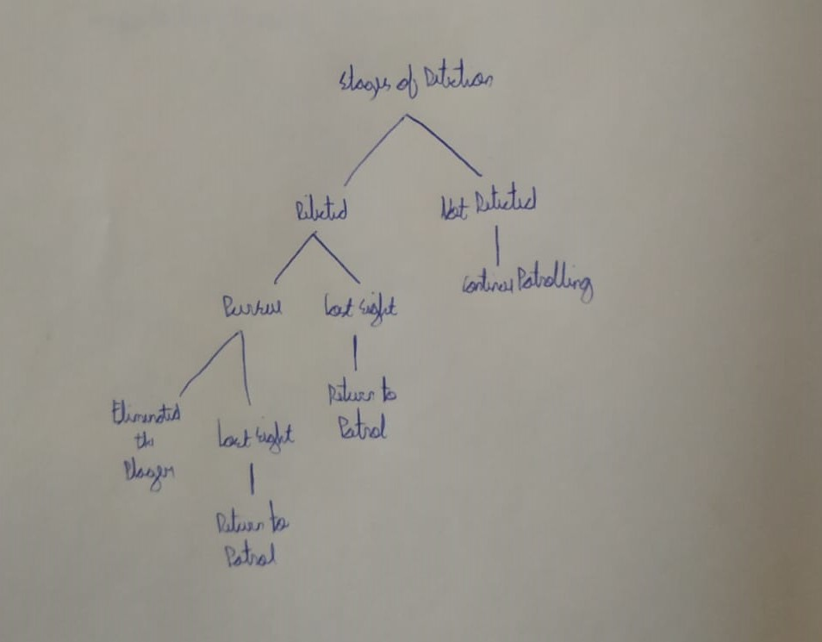Of course to do this, there will be a detection system for the enemies. The stages of detection is as follows:

# General Mechanics and Controls

## Movement:

* Basic movement: Forward, backward, left, and right with WASD.
* Interact with items: Interact with E.
* Jump: Space
* Crouch: C
* Slide: LeftControl
* Dash: F
* Aim: M2
* Shoot: M1

## Checkpoints:

For every stage/level, players will be met with checkpoints that they can interact. In this checkpoint, players can:

* Save progress
* Heal